**Muhammad Tanzil-ur-Rehman**

**BCS211037**

**Section no 1**

**Bonus Quiz**

**Task 1**

.model small

.data

str db 0ah,0dh,"$"

st db "*$"

num db 0

.code

mov ax,@data

mov ds,ax

;first half diamand

mov cl,6

mov bl,cl

l2:

add bh,1

mov cl,bh

l1:

lea dx,st

mov ah,09

int 21h

cmp bh,0

loop l1

lea dx,str

mov ah,09

int 21h

mov cl,bl

dec bl

loop l2

;second half diamand

mov cl,6

mov bl,cl

l3:

mov cl,bl

l4:

lea dx,st

mov ah,09

int 21h

loop l4

lea dx,str

mov ah,09

int 21h

mov cl,bl

dec bl

loop l3

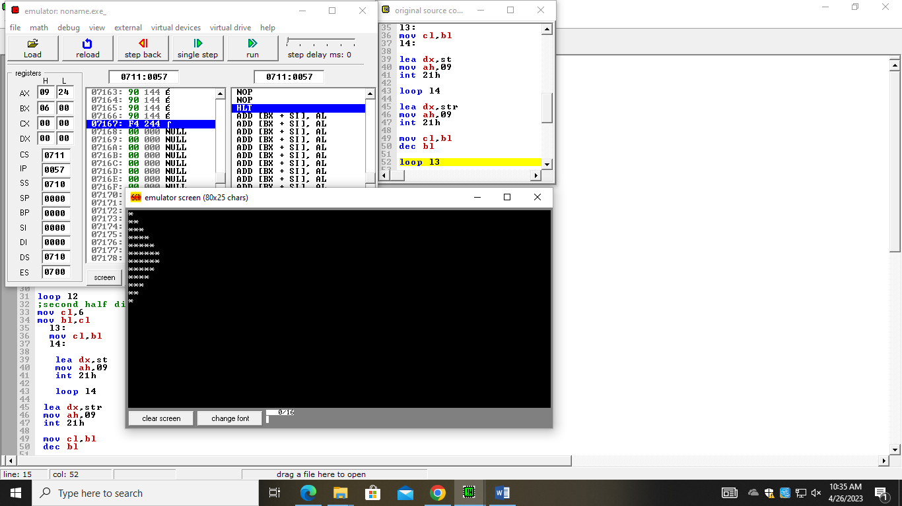

**Task 2**

.model small

.data

msg1 db 0ah,0dh,"Enter 10 Numbers in the array: $"

max db ?

min db ?

msg2 db 0ah,0dh,"Minimum odd number in array is: $"

msg3 db 0ah,0dh,"Maximum odd number in array is: $"

num1 db ?

.code

mov ax, @data

mov ds, ax

mov cx, 10

mov si, 0

mov min, 127

mov max, 0

lea dx, msg1

mov ah, 09

int 21h

l1:

mov ah, 01

int 21h

mov [num1+si], al

mov bl, al

and bl, 1

cmp bl, 0

je skip

cmp al, max

jl not_max

mov max, al

not_max:

cmp al, min

jg not_min

mov min, al

not_min:

inc si

loop l1

lea dx, msg3

mov ah, 09

int 21h

mov dl, max

mov ah, 02

int 21h

lea dx, msg2

mov ah, 09

int 21h

mov dl, min

mov ah, 02

int 21h

skip:

inc si

loop l1

mov ah, 4ch

int 21h

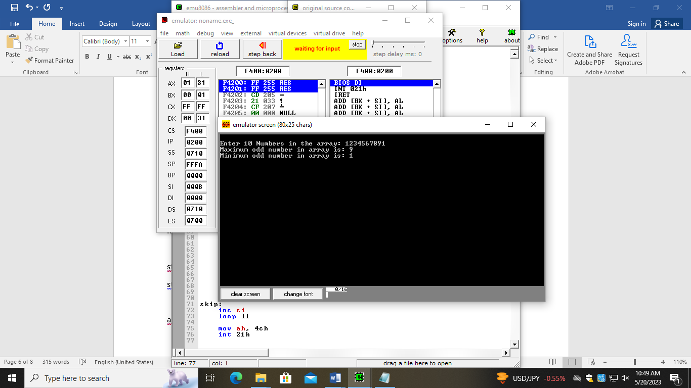

**Task 3**

.model small

.data

str db "enter 5 numbers $",0ah,0dh

str1 db ,0ah,0dh,"Reverse string $",0ah,0dh

arr dw ?

.stack 5h

.code

mov ax,@data

mov ds,ax

lea dx,str

mov ah,09

int 21h

mov cl,5

l1:

mov ah,01

int 21h

push ax

loop l1

lea dx,str1

mov ah,09

int 21h

mov cl,5

mov si,0

l2:

pop ax

mov [arr+si],ax

mov dx,ax

;add dx,48

mov ah,02

int 21h

inc si

loop l2

